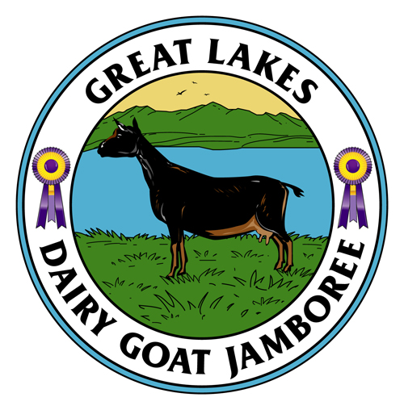
Great Lakes Dairy Goat Jamboree
Sponsorship Form
Please consider supporting our show. Sponsorships help cover the cost of sanctioning fees, prizes, judges, fairground rental, insurance and all of the other costs associated with hosting the show. In return for your generosity, your farm/herd/business name will be showcased on the Facebook page, listed on the Show website, and publicized during the Show.

Please complete this form and mail it with your payment to:
Glenys Gotthardt
3858 61st Street
Holland, MI 49423

Please make checks payable to Great Lakes Dairy Goat Jamboree. If you would prefer to pay by PayPal, please send payment to kyeema.ridge@gmail.com.

Your Name: _____________________________________________________________________________

Telephone Number: _______________________ Email: __________________________________________

Name to be publicized (e.g. Farm Name/Herd Name/Business Name, etc):

_________________________________________________________

Amount of Sponsorship:

☐ $25

☐ $50

☐ $75

☐ $100

☐ Other Amount $____________

Thank You!

